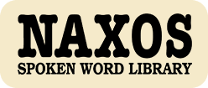

Naxos Spoken Word Library
https://www.naxosspokenwordlibrary.com/
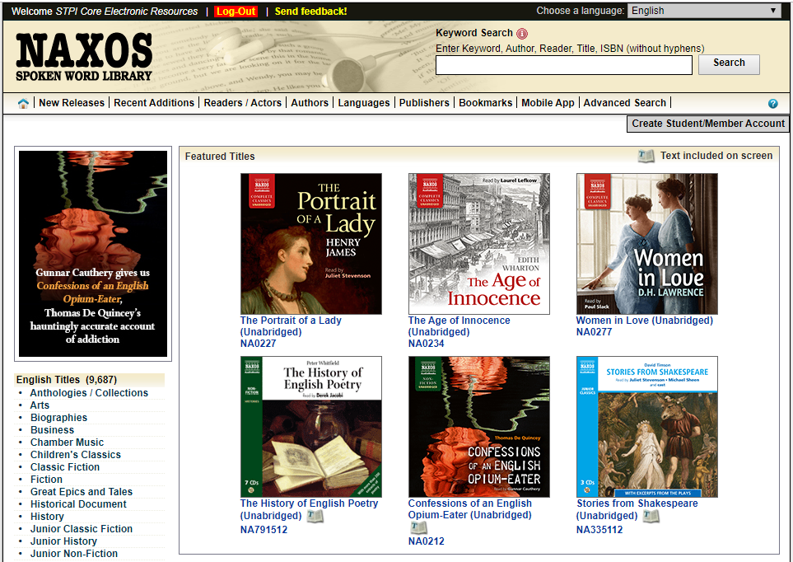
“Naxos Spoken Word Library” is an online collection of English audiobooks with titles on classic novels, plays, poetry, religion, philosophy, great epics and tales, history, biographies and music education. They are read by foreign actors, university professors and well known broadcasters in the pure English and American accents. You can enjoy your leisure time, learn English through listening and reading, or find bedside stories for your kids in it!
“Naxos Spoken Word Library” can be accessed from any computer, anywhere, anytime. With the new iPhone / iPod Touch App / Android App, subscribers can also access the service on the go.
