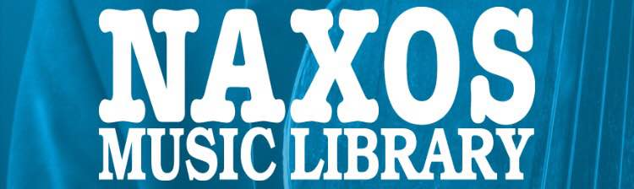 Naxos Music Library
http://www.naxosmusiclibrary.com/
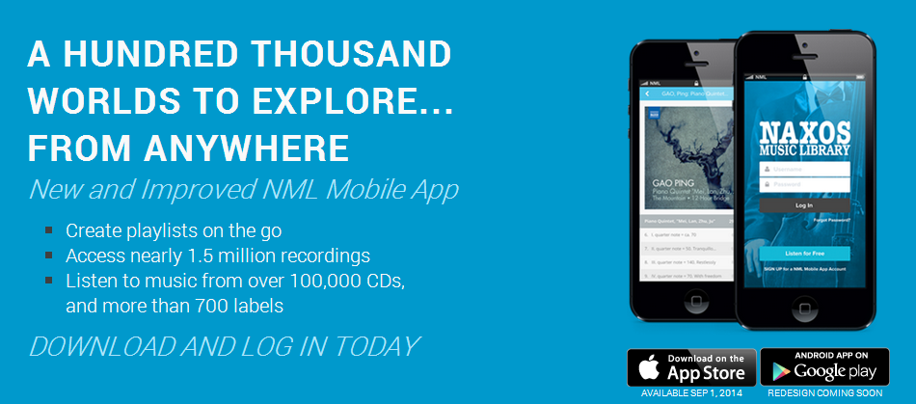
Naxos Music Library is the world's largest online classical music library. Currently, it offers More than 160,950 CD-length recordings, equivalent to 2,511,190 tracks are available, with an average addition of 1,100 CDs every month, including both standard and rare repertoire. NML provides access to the complete Naxos catalogue, as well as the complete catalogues or selected recordings of over 1,000 labels such as BIS, Capriccio, Chandos, CPO, CSO Resound, Decca, Deutsche Grammophon, Erato, Dynamic, Finlandia, Grand Piano, Hänssler Classic, Harmonia Mundi, Hungaroton, LSO Live, Marco Polo, Naïve, Naxos, New York Philharmonic, Nimbus, Nonesuch, Ondine, Orfeo, PentaTone, RCA Records, Sony Classical, Supraphon, Teldec, Universal Classics, Vanguard Classics, Warner Classics, Warner Classics - Parlophone (former EMI Classics) and many more.
NML can be accessed from any computer, anywhere, anytime. With the new iPhone / iPod Touch App / Android App, subscribers can also access the service on the go.

